# 



The quantitative investment transaction management system of FOF

**Sep 7，2016**

**System Test Report**

Contents

1

1. The Introduction 4

1.1. The Intension of the report 4

1.2. Background 4

1.3. User Group 5

1.4. Term Definition 5

1.5. Test Object 6

1.6. Test Phase 6

1.7. Reference Material 6

2. The outline of the test 6

2.1. Test Enviroment 6

2.1.1. Hardware Environment 6

2.1.2. Software Environment 6

2.1.3. Network Topology 7

2.1.4. The Method and Tools of the Test 7

2.2. Test Purpose 8

2.3. Test Execution 8

2.4. Test Personnel and Test Time 8

2.4.1. Test Personnel 8

2.4.2. Test Time 8

3. Contents and Process of Unit Test 8

3.1. Unit Test Cases and Results 8

3.2. Analysis of Unit Test Results 20

3.2.1. Unit Test Process Summary 20

3.2.2. Summary of the Results of Testing Tasks 20

3.2.3. Defects and Differentiate 20

3.2.4. The Assessment of Product Quality 21

3.2.5. The Measurement Data 21

4. Content and Process of Integration Test 21

4.1. Integration Test cases and Results 21

4.2. Analysis of Integrate Test Results 26

4.2.1. Test Process Summary 26

4.2.2. Summary of Test Results 26

4.2.3. Defects and Differentiate 27

4.2.4. The Assessment of Produft Quality 27

4.2.5. The Measurement Data 27

5. Content and Process of System Test 28

5.1. Use-case of System Test 28

5.2. Test on System Function 28

5.2.1. Sign in of normal user and manager 28

5.2.2. View all the fund market information 28

5.2.3. View single fund’s specific information 29

5.2.4. Fund Searching according to a keyword 29

5.2.5. Generating new FOF combination 29

5.2.6. View main panel of FOF management 29

5.2.7. View realtime monitor information of the FOF 30

5.2.8. View profit and loss information of the FOF 30

5.2.9. View report statistics information of the FOF 30

5.2.10. View performance attribution information of the FOF 30

5.2.11. View asset allocation information of the FOF 31

5.2.12. View position alteration information of the FOF 31

5.2.13. View performance estimation information of the FOF 31

5.2.14. Adjust position 31

5.2.15. User information management 31

5.2.16. Modify const parameter information 32

5.2.17. View risk control information 32

5.3. 系统易用性测试 32

5.4. 系统测试结果及缺陷分析 32

5.4.1. 测试结果综述 32

5.4.2. 测试结果记录及分析（待加图，每一项后面一张界面图） 33

5.4.3. 系统测试覆盖分析 54

6. 测试结论与建议 54

6.1. 功能性 54

6.2. 易用性 54

6.3. 可靠性 55

6.4. 兼容性 55

6.5. 安全性 55

# The Introduction

## The Intension of the report

There are several objectives for writing the test report.

1. Gain a general evaluation for the quality of the software by analyzing the result of the test;
2. Analyze the process, product, resources and the information of the test and provide a reference for subsequent software program;
3. Evaluate the implementation of the plan and reschedule the work;
4. Find the defects in the software system and provide some advice;
5. Analyzing the test result, we will decide whether the system meets the needs and the forecast of the customers.

## Background

FOF, the abbreviation of Fund of Funds, refers specifically to invest in other funds, FOF does not directly invest in stocks or bonds, and only in the extent of other funds, indirectly through the holders of other securities investment funds to hold stocks, bonds and other assets. FOF is new kinds of funds, which is combined with Innovation of funds product and marketing channels. FOF filters the funds through professional methods and helps investors optimize investment performance. In addition, FOF has greater flexibility in choosing investment objective, in a depressed or volatile market environment, FOF `s advantages are more obvious.

This project aims at bringing quantitative method in the selection of funds in FOF portfolio. According to the history data of funds, we can obtain each public fund`s rating and form fund pool. Secondly, we can use the market and correlative risk parameter to calculate the weights of equity funds and fixed income funds, construct FOF portfolio, show fund`s NPV and other market information to user by friendly interface, and provide FOF quantitative investment for systemic support.

The specific goals of this project are as follows:

Establishing an investment strategy database, informationizing the FOF investment. The project is designed with the index system of evaluating funds, regularly updating funds rankings, forming a fund pool, then combined with the strategy`s model, determining the fund portfolio, which efficiently and simply provides the users of FOF quantitative investment system for decision support, achieving FOF investment electronically.

Regularly monitoring the market, suggesting that risk, maximizing profit. According to market changes, the project`s system can periodically adjust fund pool and corresponding weights of each portfolio fund, meanwhile, set back line and stop line, which can tip risk and unusual products to users in a timely manner, achieving effectively control of risks.

Providing a full range of management system, users can customize FOF portfolio according to self-indexes. For the first time use, Users need to input the total asset index, risk parameters index and so on, then the system automatically generates FOF portfolio that meeting the requirements of users, and facilitates the transactions. The system also presents the user with position information, performance indicators, fund rating and other fund information, which makes it easy for users to view the market in time. In addition, the project also consists of system management and artificial adjustment function, namely, if market volatility is detected, the system automatically opens a position or increases position; if fund`s weight is negative, we can artificially set weights of 0, realizing the comprehensive management for FOF portfolio.

## User Group

Primary Audiences：

the project manager of our system

the product manager of our system

the project testers of our system

maintainer of our system

Other Audiences：

related personnel of our system

## Term Definition

1. First-order false:

Can't completely satisfy the system requirements, basic function not be fully implemented; or endanger personal safety

1. Second-order false:

Seriously affect the system requirements and the realization of the basic functions, and there is no correct way (reinstall or do not belong to the correct way to restart the software).

1. Third-order false：

Seriously affect system requirements or the realization of the basic functions, but there is a reasonable correction method (reinstall or do not belong to the correct way to restart the software).

1. Forth-order false：

Make the operator not convenient or in trouble, but it does not affect the work performed or important functions.

1. Fifth-order false：

Other problems

## Test Object

The quantitative investment transaction management system of FOF

## Test Phase

Unit testing

Integration testing

System testing

## Reference Material

《Software Requirements Specification》

《Prototype Iterations Document》

《Business Plan》

# The outline of the test



## Test Enviroment

### Hardware Environment

CPU：Intel® Core™ i3-6320 CPU @ 3.90GHz 3.90GHz

RAM：4.00 GB （3.85GB可用）

System Type：64 bit operating system，base on x64 CPU

### Software Environment

Database System：MySQL5.7.12

PC operating system：Windows8.1、Windows10

MCR(Matlab Compiler Runtime)：MCR8.5（R2015a）

### Network Topology

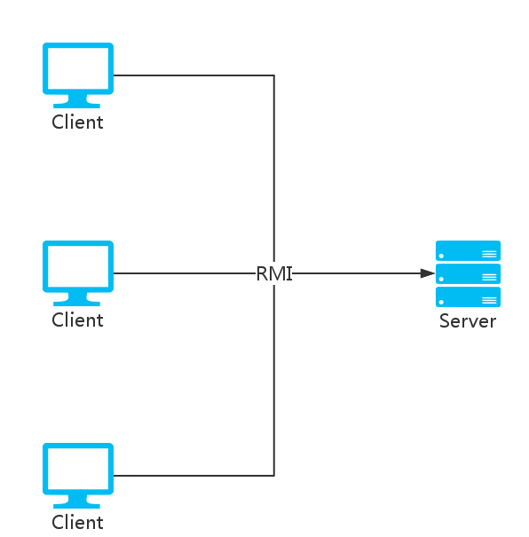

### The Method and Tools of the Test

Table 2.1.4-1 the method and tools of the test

|  |  |  |  |  |
| --- | --- | --- | --- | --- |
| Group standard | Category | Test method | Test tools | 备注 |
| Test object | Unit testing | The combination of Black box testing and White box testing Part of the testing use stub and driver. Use write box tesing for some important logic. Examined the code coverage rate. | Junit、Cobertura |  |
| Integration testing | CI | Jenkins |  |
| System testing | refer to the Software Requirements Specification to test | Random test |  |
| Test target | Function | Black box,manual |  |
| Performance | Black box,manual | test the time to processing service |
| Security | Black box,manual |  |

## Test Purpose

According to the software requirements specification，we find the deficiency andproblems of the system and verify whether the system meets the requirements specification. Additionally, we ensure that the system will meet the needs of customers in all respects before hand over, guarantee the reliability of the system and improve the quality of the software system.

## Test Execution

This test was carried out in accordance with the plan of project and test strictly and complete the test of planned target on time. During the test, we operated the test as the planned strategy rigidly. Additionally, the test group conducted the complete test for the system according to test plan and examples.

## Test Personnel and Test Time

### Test Personnel

Test engineer：Yanfei Yang

Test personnel：Xinyue Tan,Yanfei Yang

### Test Time

Begin：2016/09/05

End：2016/ 09/10

# Contents and Process of Unit Test



## Unit Test Cases and Results

|  |  |  |  |  |  |  |
| --- | --- | --- | --- | --- | --- | --- |
| ID | Name | Condition | Input | Expected  Result | Actual  Result | Remarks |
| Testcase001 | Calculate the profit rate value of alpha | / | the profit rate of China Growth(000001) and the Total Fund Index in 2015 | 0.1345 | 0.1345 |  |
| Testcase002 | Calculate the profit rate value of alpha | / | the profit rate of Huitianfu real debt A (000122) and the Total Fund Index in 2015 | 0.0708 | 0.0708 |  |
| Testcase003 | Calculate the profit rate value of beta | / | the profit rate of China Growth(000001) and the Total Fund Index in 2015 | 0.7157 | 0.7157 |  |
| Testcase004 | Calculate the profit rate value of beta | / | the profit rate of Huitianfu real debt A (000122) and the Total Fund Index in 2015 | 0.0233 | 0.0233 |  |
| Testcase005 | Calculate the profit rate value of sharpe | / | the profit rate of China Growth(000001) and the Total Fund Index in 2015 | -0.025 | -0.025 |  |
| Testcase006 | Calculate the profit rate value of sharpe | / | the profit rate of Huitianfu real debt A (000122) and the Total Fund Index in 2015 | 0.127 | 0.127 |  |
| Testcase007 | Calculate the profit rate value of treynor | / | the profit rate of China Growth(000001) and the Total Fund Index in 2015 | -0.123 | -0.123 |  |
| Testcase008 | Calculate the profit rate value of treynor | / | the profit rate of Huitianfu real debt A (000122) and the Total Fund Index in 2015 | 1.179 | 1.179 |  |
| Testcase009 | Calculate the profit rate value of Jensen | / | the profit rate of China Growth(000001) and the Total Fund Index in 2015 | 0.135 | 0.135 |  |
| Testcase010 | Calculate the profit rate value of Jensen | / | the profit rate of Huitianfu real debt A (000122) and the Total Fund Index in 2015 | 0.071 | 0.071 |  |
| Testcase011 | Calculate the average of profit rate | / | the profit rate of China Growth (000001) in 2015 | -0.021 | -0.021 |  |
| Testcase012 | Calculate the average of profit rate | / | the profit rate of Huitianfu real debt A (000122) in 2015 | 0.025 | 0.025 |  |
| Testcase013 | Calculate the standard deviation of profit rate | / | the profit rate of China Growth(000001) and the Total Fund Index in 2015 | 1.393 | 1.393 |  |
| Testcase014 | Calculate the standard deviation of profit rate | / | the profit rate of Huitianfu real debt A (000122) and the Total Fund Index in 2015 | 0.087 | 0.087 |  |
| Testcase015 | Calculate the year wave rate of profit rate | / | the profit rate of China Growth(000001) and the Total Fund Index in 2015 | 3.46 | 3.46 |  |
| Testcase016 | Calculate the year wave rate of profit rate | / | the profit rate of Huitianfu real debt A (000122) and the Total Fund Index in 2015 | 0.0233 | 0.0233 |  |
| Testcase017 | Calculate the profit rate index | / | the profit rate of Huitianfu real debt A (000122) in 2015 | 0.8  2.54  2.82  6.1  25.3  38.14  40.08  3.65  40.08  11.1 | 0.8  2.54  2.82  6.1  25.3  38.14  40.08  3.65  40.08  11.1 |  |
| Testcase018 | Calculate the profit rate index | / | the profit rate of China Growth(000001) and the Total Fund Index in 2015 | 1.37  3.67  5.31  -8.98  13.23  20.42  25.66  -17.47  485.54  14.58 | 1.37  3.67  5.31  -8.98  13.23  20.42  25.66  -17.47  485.54  14.58 |  |
| Testcase019 | get the history info of funds | / | 000001  UnitType.DAY  2016-03-01  2016-03-10 | 1.053,1.15  1.083,2.85  1.083,0.0  1.074,-0.83  1.083,0.84  1.083,0  1.074,-0.83  1.064,-0.93 | 1.053,1.15  1.083,2.85  1.083,0.0  1.074,-0.83  1.083,0.84  1.083,0  1.074,-0.83  1.064,-0.93 |  |
| Testcase020 | get the history info of funds | / | 000001  UnitType.WEEK  2016-03-01  2016-03-10 | 1.074,-0.2766  1.064,-0.927  1.105,3.8567 | 1.074,-0.2766  1.064,-0.927  1.105,3.8567 |  |
| Testcase021 | get the history info of funds | / | 000001  UnitType.WEEK  5 | 1.136，-0.09  1.134，-0.18  1.131，-0.26  1.133，-0.18  1.14，0.62 | 1.136，-0.09  1.134，-0.18  1.131，-0.26  1.133，-0.18  1.14，0.62 |  |
| Testcase022 | get the history info of funds to be shown in the chart | / | 000001  UnitType.DAY  TimeType.  ONE_MONTH  CharType.NET_  WORTH_  PROFORMANCE_  UNIT | 1.125,1.125,1.125  1.129,1.129,1.133  1.129,1.127,1.130  1.122,1.126,1.124  1.126,1.136,1.142  1.137,1.153,1.170  1.140,1.150,1.165  1.141,1.149,1.164 | 1.125,1.125,1.125  1.129,1.129,1.133  1.129,1.127,1.130  1.122,1.126,1.124  1.126,1.136,1.142  1.137,1.153,1.170  1.140,1.150,1.165  1.141,1.149,1.164 |  |
| Testcase023 | get the asset allocation of funds | / | 000001 | 29.39  52.3  14.17  14.1  25.2  7.94  1.64  2.9  51.27  56.16 | 29.39  52.3  14.17  14.1  25.2  7.94  1.64  2.9  51.27  56.16 |  |
| Testcase024 | get the stock allocation of funds | / | 000001  HoldingType.  STOCK | 002051，3.32  000876，2.0  002175，1.77  600804，1.46  600887，1.14  600521，1.13  000963，1.06  300156，0.96  002311，0.92  600056，0.9 | 002051，3.32  000876，2.0  002175，1.77  600804，1.46  600887，1.14  600521，1.13  000963，1.06  300156，0.96  002311，0.92  600056，0.9 |  |
| Testcase025 | get the industry allocation of funds | / | 000001  HoldingType.  INDUSTRY | C，32.39  I，4.37  E，4.53  F，3.03  K，2.51  D，2.46  B，2.32  R，1.45  J，0.97  G，0.74 | C，32.39  I，4.37  E，4.53  F，3.03  K，2.51  D，2.46  B，2.32  R，1.45  J，0.97  G，0.74 |  |
| Testcase026 | fund search | / | ‘大数据’ | 001113，大数据100；  001242，博时大数据100A  001243，南方大数据A  001420，南方大数据C  001564，东方红大数据  001637，嘉实腾讯自选股大数据策略股票  001734，广发百发大数据成长混合A  001735，广发百发大数据成长混合E  001741，广发百发大数据精选混合A  001742，广发百发大数据精选混合E  002263，泰达宏利大数据混  002269，银华大数据  002588，博时银智大数据100  519132，海富通东财大数据混合 | 001113，大数据100；  001242，博时大数据100A  001243，南方大数据A  001420，南方大数据C  001564，东方红大数据  001637，嘉实腾讯自选股大数据策略股票  001734，广发百发大数据成长混合A  001735，广发百发大数据成长混合E  001741，广发百发大数据精选混合A  001742，广发百发大数据精选混合E  002263，泰达宏利大数据混  002269，银华大数据  002588，博时银智大数据100  519132，海富通东财大数据混合 |  |
| Testcase027 | get the return statistics of funds | / | 2015-01-01  2016-09-06  UnitType.DAY  上证基金指数 | {238.0，172.0，0.0，410.0}、{58.05，41.95，0.0，100}  {0.46，-0.52，0.0，0.05}  {0.74，0.73，0.0，87.98}  {10.0，6.0，0.0，0.0}  {2.38，1.72，0.0,0.0}  {4.89，-1.8，-6.69，2015-07-08}  {4.71，-2.57，-7.27，2015-01-19}  {4.25，5.18，0.93，2016-06-04}  {-4.8，1.96，6.76，2015-07-09}  {-4.21，-1.04，3.17，2015-09-16}  {-3.77，1.86，5.63，2015-07-10} | {238.0，172.0，0.0，410.0}、{58.05，41.95，0.0，100}  {0.46，-0.52，0.0，0.05}  {0.74，0.73，0.0，87.98}  {10.0，6.0，0.0，0.0}  {2.38，1.72，0.0,0.0}  {4.89，-1.8，-6.69，2015-07-08}  {4.71，-2.57，-7.27，2015-01-19}  {4.25，5.18，0.93，2016-06-04}  {-4.8，1.96，6.76，2015-07-09}  {-4.21，-1.04，3.17，2015-09-16}  {-3.77，1.86，5.63，2015-07-10} |  |
| Testcase028 | get the profit analyse of FOF | / | TimeType.  ONE_MONTH | 0.83  -1.69  3  5  0  4  7  11  -22.43  0  0.16  0.01  0.94  0.28  0.24  0.46  0.31  0.88  1.36  0.28 | 0.83  -1.69  3  5  0  4  7  11  -22.43  0  0.16  0.01  0.94  0.28  0.24  0.46  0.31  0.88  1.36  0.28 |  |
| Testcase029 | get the profit analyse of FOF |  | TimeType.  ONE_YEAR | 10.38  3.32  0.02  6  8  -0.02  4  8  10.76  3.44  0  1.44  0.01  0.85  0.02  0.29  0.05  0.25  0.72  0.08  0.02 | 10.38  3.32  0.02  6  8  -0.02  4  8  10.76  3.44  0  1.44  0.01  0.85  0.02  0.29  0.05  0.25  0.72  0.08  0.02 |  |
| Testcase030 | get the newest weight of all funds in the FOF | / | / | 159910，5.74  165511，6.31  340006，5.4  050021，5.87  070023，5.68  000122，10.32  166008，8.93  092002，8.64  233005，11.77  000131，11.21 | 159910，5.74  165511，6.31  340006，5.4  050021，5.87  070023，5.68  000122，10.32  166008，8.93  092002，8.64  233005，11.77  000131，11.21 |  |
| Testcase031 | get the codes of all funds in the FOF | / | / | 050021  070023  159910  165511  340006  000122  000131  092002  166008  233005 | 000011  000012 | wrong return value |
| Testcase032 | get the performance attribution of FOF | / | / | 1.2326  567.9052  7.0  7.0  1.4397  567.9052  8.1761  6.3993  1.1769  16.813 | 1.2326  567.9052  7.0  7.0  1.4397  567.9052  8.1761  6.3993  1.1769  16.813 |  |
| Testcase033 | add user | coressponding user hasn’t existed in database | yyf  male  yyf  123456  MANAGER | return tips that add success, add corresponding user information in database | return tips that add success, add corresponding user information in database |  |
| Testcase034 | add user | coressponding user has existed in database | yyf  male  yyf  123456  MANAGER | return tips that user existed | return tips that user existed |  |
| Testcase035 | delete user | coressponding user has existed in database | yyf  male  yyf  123456  MANAGER | return tips that delete success, delete corresponding user information from database | return tips that delete success, delete corresponding user information from database |  |
| Testcase036 | delete user | coressponding user hasn’t existed in database | yyf  male  yyf  123456  MANAGER | return tips that user not found | return tips that user not found |  |
| Testcase037 | update user infomation | coressponding user has existed in database | yyf  male  yyf  123456  NORMAL | return tips that database update success, update user information in database | return tips that database update success, update user information in database |  |
| Testcase038 | update the net worth of funds | database table has established | / | return tips that database update success，update net worth of all funds in database | return tips that database update success，update net worth of all funds in database | caused by multithreading and concurrence |
| Testcase039 | update rank information of funds | fund information has existed in database | / | return tips that update success, add rank information of fund in database, and the rank is roughly the same as that in ChenXing. | return tips that update success, add rank information of fund in database, and the rank is different from that in ChenXing. | caused by data、algorithm |
| Testcase040 | get the runtime estimate net worth information of fund | / | 000001 | the net worth and the rise of the corresponding fund at present | the net worth and the rise of the corresponding fund at present |  |
| Testcase041 | get the history risk information of FOF | / | / | the history risk information | the history risk information |  |

## Analysis of Unit Test Results

### Unit Test Process Summary

Mainly using stub and driver to guide test process. Using stub to replace some database operation to make logic test more easier.The whole test process is smoothly，but there’s some repetition codes to make the process tedious and boring.Hope to find better tool to handle test.

### Summary of the Results of Testing Tasks

Ensure that all unit pass the test of automation method. That means it ensures the method has the system expected input/output and invariants.

### Defects and Differentiate

chart 3.2.3-1important defect analysis of the unit test

|  |  |  |  |  |
| --- | --- | --- | --- | --- |
| Module Name | Defect ID | Brief Description | The Result of Analysis | The Test Pass |
| Fund rating | 001 | the rating result is different from that in ChenXing | the difference between data source | Pass |
| Update net worth of the fund | 002 | the process is so slowly and update repeatly | caused by multithreading and concurrence | Pass |

chart 3.2.3-2residue on the unresolved issue list of the unit test

|  |  |  |  |  |
| --- | --- | --- | --- | --- |
| Module Name | Defect ID | Nature | Brief Description | Analysis of Reasons |
| None |  |  |  |  |

### The Assessment of Product Quality

1. Overview: All of the Unit test pass the automation test, and reach the expected target, what’s more, it has reached the basic implementation coverage of complex logic code.
2. Remarks：The Unit Test focus on FOF generation process and the calculationg of the main index.Other unimportant logic did not implement the complete coverage of codes and branchs
3. Conclusion: The quality has already reached the standards, so we can carry out the subsequent packaging installation work.

### The Measurement Data

1. Defect Metrics：defect number is two，5% of the whole test numbers，and they are roughly fixed after adjustments.
2. Coverage Metric：Using Maven Cobertura to handle this.The total coverage rate is 70% except some getter and setter method.Reaching the demand of normal project;

# Content and Process of Integration Test



## Integration Test cases and Results

|  |  |  |  |  |  |  |
| --- | --- | --- | --- | --- | --- | --- |
| ID | Name | Condition | Input | Expected  Result | Actual  Result | Remarks |
| Testcase001 | examine the username and password | RMI connection is valid, and there a user named yyf identified by 123456 in the database | yyf  123456 | return  UserInfo | return  UserInfo | / |
| Testcase002 | examine the username and password | RMI connection is valid, and there a user named yyf not identified by 000000 in the database | yyf  000000 | throw exceptio, return tips that password is wrong | throw exceptio, return tips that password is wrong | / |
| Testcase003 | examine the username and password | RMI connection is valid，there is no user named yyf in database | yyf  123456 | throw exception. return tips that user not found | throw exception. return tips that user not found | / |
| Testcase004 | add user | RMI connection is valid，there is no user named yyf in database | yyf  123456  Gender.MALE  MANAGER | return tips that user add success. Add user information in database | return tips that user add success. Add user information in database | / |
| Testcase005 | add user | RMI connection is valid，there is a user named yyf in database | yyf  123456  Gender.MALE  MANAGER | throw exception. return tips that user has existed | throw exception. return tips that user has existed | / |
| Testcase006 | modify user information | RMI connection is valid，there is a user named yyf in database | yyf  123456  Gender.MALE  NORMAL | return tips that user modify success. Modify user information in database | return tips that user modify success. Modify user information in database | / |
| Testcase007 | modify user informantion | RMI connection is valid，there is no user named yyf in database | yyf  123456  Gender.MALE  NORMAL | throw exception. return tips that user not found | throw exception. return tips that user not found | / |
| Testcase008 | generate new FOF combination | RMI connection is valid，there is no FOF combination in database | 10000000000  CPPI  中风险 | generate coressponding FOF combination and show back-test result | generate coressponding FOF combination and show back-test result | / |
| Testcase009 | generate new FOF combination | RMI connection is valid，there is no FOF combination in database | 10000000000  风险平价  自定义  0.9  2 | generate coressponding FOF combination and show back-test result | generate coressponding FOF combination and show back-test result | / |
| Testcase010 | get FOF realtime monitor information | RMI connection is valid，there is some FOF history data in database | / | the newest information of the funds in FOF combination | the newest information of the funds in FOF combination | / |
| Testcase010 | get FOF profit and loss information | RMI connection is valid，there is some FOF history data in database | 2015-01-05  2016-09-06  上证基金指数 | the profit and loss information and risk information of FOF combination in the coressponding period | the profit and loss information and risk information of FOF combination in the coressponding period | / |
| Testcase011 | get FOF report statistics information | RMI connection is valid，there is some FOF history data in database | 2016-01-01  2016-09-09  UnitType.DAY  上证基金指数 | the report stastics information of FOF combination in the coressponding period | the report stastics information of FOF combination in the coressponding period | / |
| Testcase012 | get FOF asset allocation information | RMI connection is valid，there is some FOF history data in database | / | the historical profit info and net worth of the funds in the FOF combination | the historical profit info and net worth of the funds in the FOF combination | / |
| Testcase013 | get FOF postion alteration information | RMI connection is valid，there is some FOF history data in database | / | the historical position alteration information, including manual and automatic alteration | the historical position alteration information, only including manual alteration | automatic alteration not add in the log |
| Testcase014 | get FOF risk profit index information of performance estimation | RMI connection is valid，there is some FOF history data in database | / | the risk profit index information of the funds in the FOF combination | the risk profit index information of the funds in the FOF combination | / |
| Testcase015 | get FOF invest type information of performance estimation | RMI connection is valid，there is some FOF history data in database | / | the invest type information of the funds in the FOF combination | the invest type information of the funds in the FOF combination | / |
| Testcase016 | get the classified information of all funds | RMI connection is valid，there is fund information in database | / | the classified information of all funds | the classified information of all funds | / |
| Testcase017 | get the realtime information of all funds | RMI connection is valid，there is fund information in database | / | the realtime information of all funds | the realtime information of all funds | / |
| Testcase019 | get historical unit net worth and total net worth information of funds | RMI connection is valid，there is fund information in database | 000001 | historical unit net worth and total net worth information of coressponding fund | historical unit net worth and total net worth information of coressponding fund | / |
| Testcase020 | get basic information of funds | RMI connection is valid，there is fund information in database | 000005 | basic information of coressponding fund | basic information of coressponding fund | 无 |
| Testcase021 | get asset allocation information of funds | RMI connection is valid，there is fund information in database | 000005 | asset allocation information of coressponding fund | asset allocation information of coressponding fund | 无 |
| Testcase022 | get performance estimation information of funds | RMI connection is valid，there is fund information in database | 000005 | performance estimation information of coressponding fund | performance estimation information of coressponding fund |  |
| Testcase023 | get Million wave chart information of funds | RMI connection is valid，there is fund information in database | 000005 | Million wave chart information of coressponding fund | Million wave chart information of coressponding fund |  |
| Testcase024 | get const parameter information | RMI connection is valid，there is const parameter information in database | / | const parameter information | const parameter information |  |
| Testcase025 | update const parameter information | RMI connection is valid，there is const parameter information in database | new const parameter inforamtion | return tips that update success, update const parameter in database | return tips that update success, update const parameter in database |  |
| Testcase026 | adjust position | RMI connection is valid，there is FOF information in database | correct position weight | return tips that adjust success, add new adjust request in database | return tips that adjust success, add new adjust request in database |  |
| Testcase027 | adjust position | RMI connection is valid，there is FOF information in database | wrong position weight(the sum of the weight bigger than 100%) | return tips that weight information is wrong, there no operation in database | return tips that weight information is wrong, there no operation in database |  |

## Analysis of Integrate Test Results

### Test Process Summary

At the end of the architecture design phase, we develop Stub and Driver for logic layer.Due to Hibernate framework, the code implement of data layer is simple, and there is small possibility of defects in data layer, so we didn’t completely develop stub for data layer. In the construction phase, the rest all adopt the top-down developing structure, after the development of each level, we use the Stub of the next level for maven build. Step by step, the lower level are integrated into the completed code.

### Summary of Test Results

Task 1：

Description：Integrate logic layer and data layer

Operation：To replace part using data layer stub with real code implement. Writing test code ,and use maven build to conduct integrate test.

Conclusion：pass，reach the demand

Problem：None。

Tase 2：

Description：Integrate user interface layer and logic layer

Operation：To replace stub used in user layer with real code implement, completing system integrate

Conclusion：pass，reach the demand

Problem：None。

### Defects and Differentiate

chart 4.2.3-1serious defect analysis of the integration test

|  |  |  |  |  |
| --- | --- | --- | --- | --- |
| Module Name | Defect ID | Brief Description | The Result of Analysis | The Test Pass |
| FOFAssetAllo  cation.Change  Postition | 013 | the return position alteration not including system automatic alteration | Do not add automatic alteration in system log | Fail->Pass |

chart 4.2.3-2 residue defects and unresolved issues list of the integration test

|  |  |  |  |  |
| --- | --- | --- | --- | --- |
| Module Name | Defect ID | Nature | Brief Description | Analysis Reasons |
| None |  |  |  |  |

### The Assessment of Produft Quality

1. Overview： We use Jenkins to conduct continuous integration in the integration process. We use stub to replace some class which is not implemented, and the stub will be replaced with implemented class eventually. The final build result is SUCCESS.
2. Remarks：Caused by the lack of a fixed server, some commit operation is not trigger integration test in the continuous integration process immediately, and did not fix this kind of defects immediately. But there no such big influence on the final result.
3. Conclusion：achieve expected target，pass the test。

### The Measurement Data

1. Defect metrics in integration test：

Serious defect：0

Common defect：1

No-impact defect：0

1. Coverage metric in integration test：

Number of tested module：2

Number of module：2

Coverage of module：100%

# Content and Process of System Test



## Use-case of System Test

System is adopting the method of equivalence class division and boundary value testing system test,, according to the specification, divided into the following equivalence class:

1. Sign in of normal user and manager
2. View all the fund market information
3. View single fund’s specific information
4. Fund Searching according to a keyword
5. Generating new FOF combination
6. View main panel of FOF management
7. View realtime monitor information of the FOF
8. View profit and loss information of the FOF
9. View report statistics information of the FOF

10、View performance attribution information of the FOF

11、View asset allocation information of the FOF

12、View position alteration information of the FOF

13、View performance estimation information of the FOF

14、User adjust position

15、User information management

16、Modify const parameter information

17、View risk control information

## Test on System Function

### Sign in of normal user and manager

Test method：

1. Input correct username and password, see the login result
2. Input not existed username, see the login result
3. Input correct username and wrong password, see the login result

### View all the fund market information

Test method：

1. Select market infomation，view the top list information
2. Select a single fund,view the net worth and profit trend
3. Select different fund class,view the update of the top list
4. Select different fund, different fund class, view the panel result
5. Double click a fund ,view the specific information of single fund
6. Remarks：The information need to compare with the data from authority (such as winde)

### View single fund’s specific information

Test method：

1. 进入基金详细信息界面，查看基金的基本信息、收益率指标、评级信息、效绩评估万元波动图、资产配置信息是否正确
2. 在资产配置小项中分别选择分布、重仓债权、重仓股票、行业配置，查看显示信息是否正确
3. 将数据移入万元波动图，查看万元波动图交互信息是否正确

备注：查看的信息需简单与较为权威的机构（如winde）的数据进行对比

### Fund Searching according to a keyword

测试方法：

1. 分别在不同的界面在搜索框中输入关键字信息，查看能否正确显示返回的基金条目信息
2. 单击返回的基金条目中的一条，查看能否正确进入对应基金的详细信息界面
3. 不断重复以上操作，查看结果是否正确

### Generating new FOF combination

测试方法：

1. 在偏好设置里输入正确的总资产，分别选择CPPI和风险平价策略，在CPPI中分别选择高风险、中风险、低风险和自定义风险偏好，之后查看大类资产配置、小类资产配置、回测结果反馈信息是否正确，输入正确的名字后点击生成后查看反馈信息
2. 在偏好设置里尝试输入错误的资产数（比如负数、其他不能识别的字符等），查看系统反馈
3. 在生成组合中途退出系统或注销登录，查看系统反馈
4. 在生成组合中途进入其他界面，查看系统反馈

备注：进行不同方案的测试前，需要把数据库中已生成的FOF组合信息删除，不然无法正确进入生成组合界面

### View main panel of FOF management

测试方法：

1. 选择组合管理，查看显示FOF组合基本信息、小项显示信息、总回报信息是否正确。
2. 分别点击各种小类别信息，查看界面跳转是否正确。
3. 将鼠标移入总回报图里，查看图表交互信息是否正确。

### View realtime monitor information of the FOF

测试方法：

1. 点击FOF组合实时监控功能，查看FOF内组合内基金信息是否正确显示
2. 单击一只基金，查看对应基金的净值表现图是否正确显示
3. 更改图表中的复权信息、单位信息、区间信息，查看图表是否正确显示
4. 更改业绩基准，查看显示信息是否正确
5. 不断重复、结合以上操作，查看系统是否正常显示

### View profit and loss information of the FOF

测试方法：

1. 点击FOF组合盈亏分析功能，查看收益信息、风险指标信息是否正确显示
2. 更改开始日期和结束日期，查看信息是否正确更新
3. 更改业绩基准，查看信息是否正确更新
4. 不断重复、结合以上操作，查看系统是否正常显示

### View report statistics information of the FOF

测试方法：

1. 点击FOF组合回报统计功能，查看统计信息、回报统计图表是否正确显示
2. 更改开始日期、结束日期、统计周期，查看图表信息是否正确更新
3. 更改业绩基准，查看图表信息是否正确更新
4. 将鼠标移入回报统计图里，查看图表交互信息是否正确
5. 不断重复、结合以上操作，查看系统是否正常显示

### View performance attribution information of the FOF

测试方法：

1. 点击FOF组合业绩归因功能，查看图表信息是否正确显示
2. 更改开始日期、结束日期，查看图表信息是否正确更新
3. 更改业绩基准，查看图表信息是否正确更新
4. 不断重复、结合以上操作，查看系统是否正常显示

### View asset allocation information of the FOF

测试方法：

1. 点击FOF组合资产配置功能，查看FOF组合内基金收益信息、净值表现图是否正确显示
2. 单击一只基金，查看基金对应的净值表现图是否正常更新
3. 更改净值表现图中的复权信息、单位信息、区间信息，查看净值表现图是否正常更新
4. 不断重复、结合以上操作，查看系统是否正常显示

### View position alteration information of the FOF

测试方法：

1. 点击FOF组合持仓变动功能，查看FOF组合历史调仓信息是否正确显示

### View performance estimation information of the FOF

测试方法：

1. 点击FOF组合效绩评估功能，查看FOF组合内对应基金的风险收益指标是否正确显示
2. 点击投资风格选项，查看FOF组合内对应基金的投资风格是否正确显示
3. 反复切换两个选项，查看系统是否正常显示

### Adjust position

测试方法：

1. 点击FOF组合仓位调整功能，查看FOF组合内基金的当前权重是否正确显示
2. 使用滑动条组件调整基金权重配比，查看组件是否能够正确使用和显示信息是否正确
3. 调整到一个总和小于100%的配比点击完成调整，查看反馈信息
4. 尝试调整到一个总和大于100%的配比点击完成调整，查看反馈信息

### User information management

测试方法：

1. 点击账户管理信息功能，查看系统用户信息是否正常显示
2. 点击添加账户，输入新的账户信息，点击确认添加，查看系统反馈信息
3. 点击添加账户，输入数据库中已存在的账户信息，点击确认添加，查看系统反馈信息
4. 点击修改账户，更改已存在的账户信息，点击确认，查看系统反馈信息
5. 点击删除账户，删除存在的部分账户，点击确认，查看系统反馈信息
6. 不断重复、结合以上操作，查看系统是否正常显示

### Modify const parameter information

测试方法：

1. 点击参数修改功能，查看系统内参数信息显
2. 修改参数中的一个或多个，点击确认更新，查看系统反馈信息

### View risk control information

测试方法：

1. 点击风险控制功能，查看界面图表信息是否显示正常

## 系统易用性测试

概述：对于所有系统测试用例，采用相同的系统易用性测试方法。

测试重点：可操作选项提示的信息的正确性、一致性、可理解性；部分用例需要的操作快捷键的可用性、易用性。

测试方法：检查每个按钮及其他可操作选项，核对显示信息和提示信息；测试操作流程的复杂性和可理解性

## 系统测试结果及缺陷分析



### 测试结果综述

错误分布情况

|  |  |  |  |  |
| --- | --- | --- | --- | --- |
| 错误类型 | 发现错误数目 | 修改错误数目 | 修复率 | 占总错误比率 |
| 一级错误 | 0 | 0 | / | / |
| 二级错误 | 0 | 0 | / | / |
| 三级错误 | 2 | 2 | 100% | 67% |
| 四级错误 | 1 | 1 | 100% | 33% |
| 五级错误 | 0 | 0 | / | / |
| 错误合计 | 3 | 3 | 100% | 100% |

### 测试结果记录及分析（待加图，每一项后面一张界面图）

#### Sign in of normal user and manager

1. Input correct username and password, see the login result



1. Input not existed username, see the login result



1. Input correct username and wrong password, see the login result



#### View all the fund market information

1. Select market infomation，view the top list information

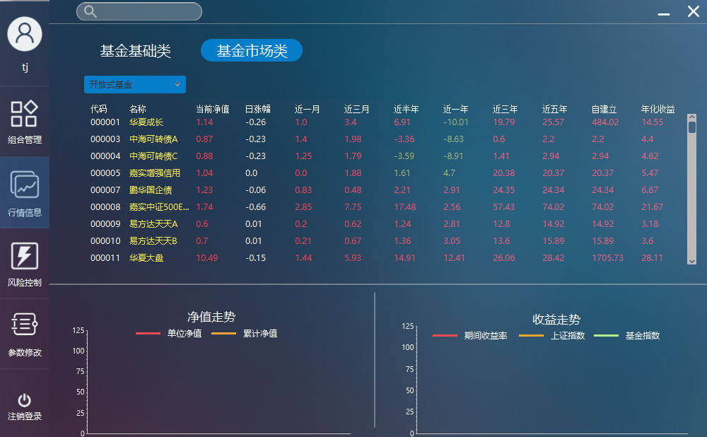

1. Select a single fund,view the net worth and profit trend

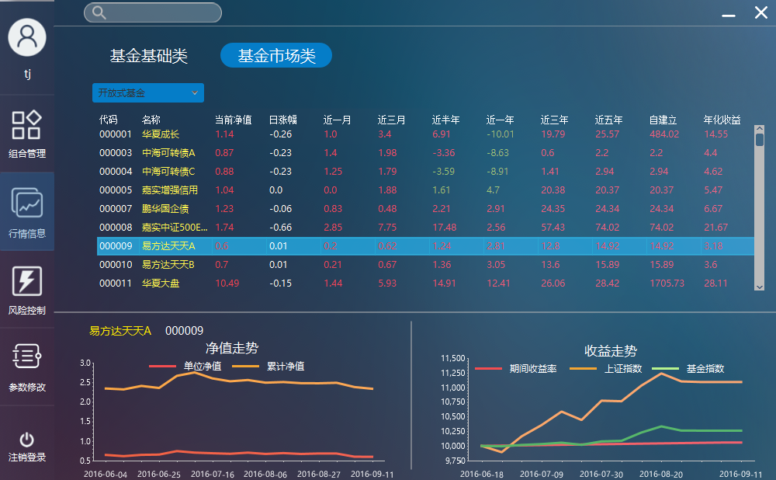

1. Select different fund class,view the update of the top list

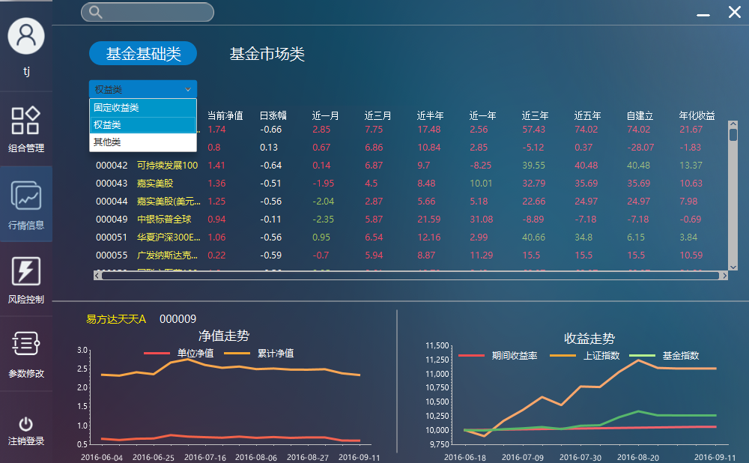

1. Double click a fund ,view the specific information of single fund

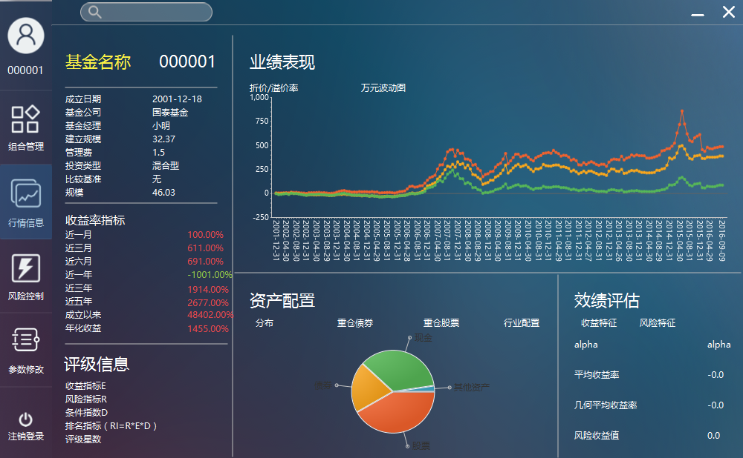

#### View single fund’s specific information

1. 进入基金详细信息界面，查看基金的基本信息、收益率指标、评级信息、效绩评估万元波动图、资产配置信息是否正确



1. 在资产配置小项中分别选择分布、重仓债权、重仓股票、行业配置，查看显示信息是否正确

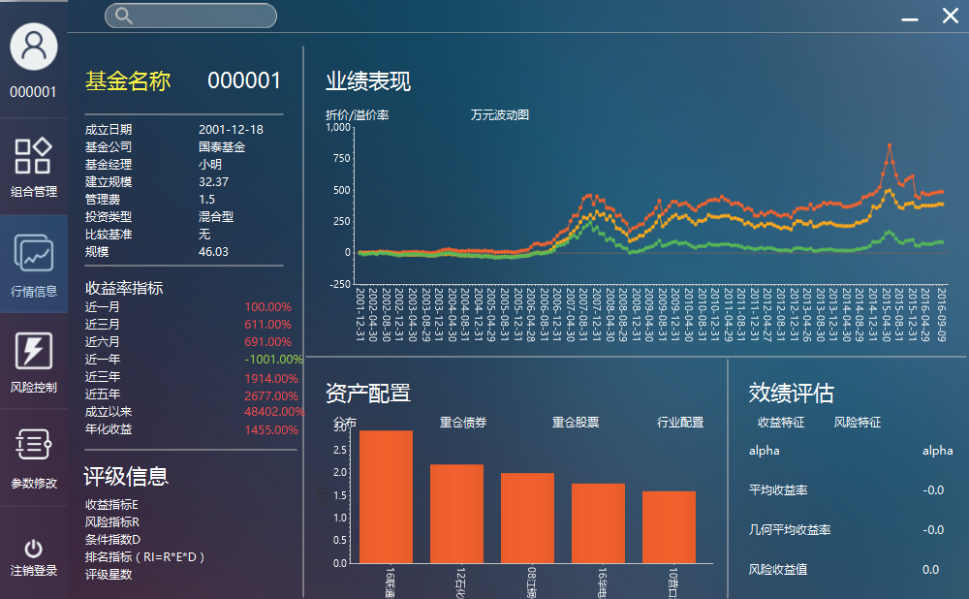

#### Fund Searching according to a keyword

1. 分别在不同的界面在搜索框中输入关键字信息，查看能否正确显示返回的基金条目信息

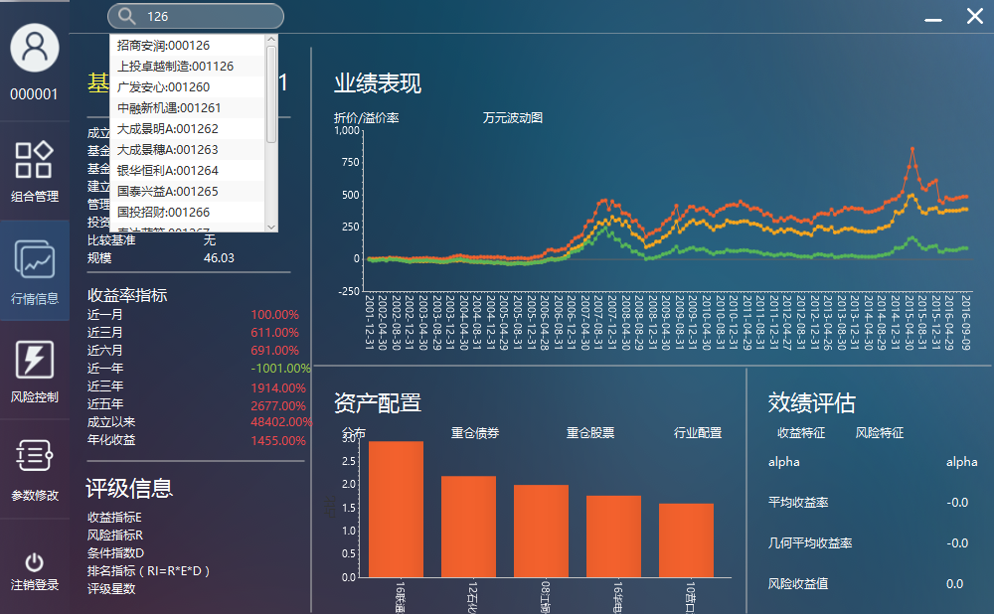

1. 单击返回的基金条目中的一条，查看能否正确进入对应基金的详细信息界面

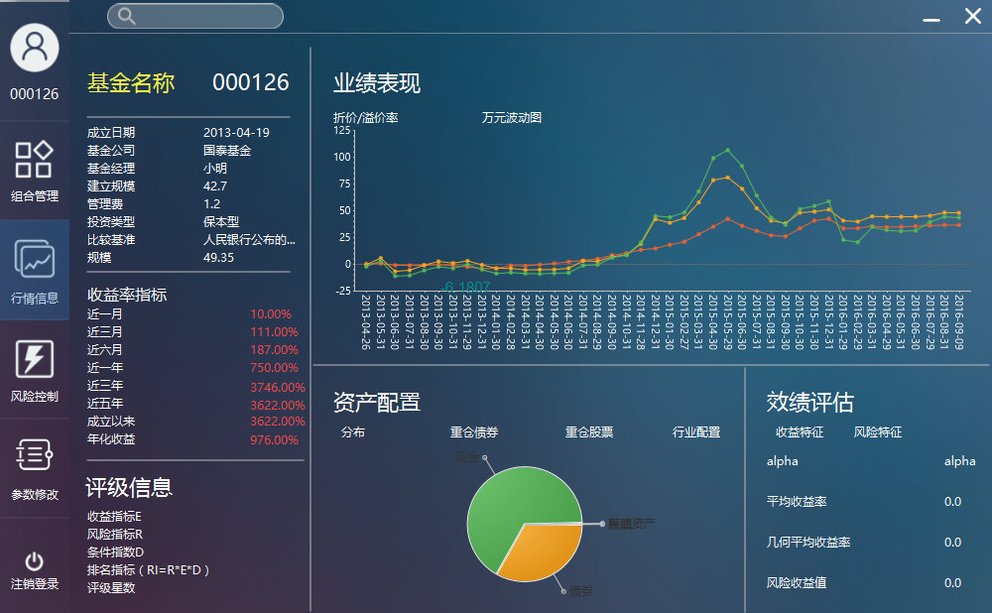

#### Generating new FOF combination

1. 在偏好设置里输入正确的总资产，分别选择CPPI和风险平价策略，在CPPI中分别选择高风险、中风险、低风险和自定义风险偏好，之后查看大类资产配置、小类资产配置、回测结果反馈信息是否正确，输入正确的名字后点击生成后查看反馈信息

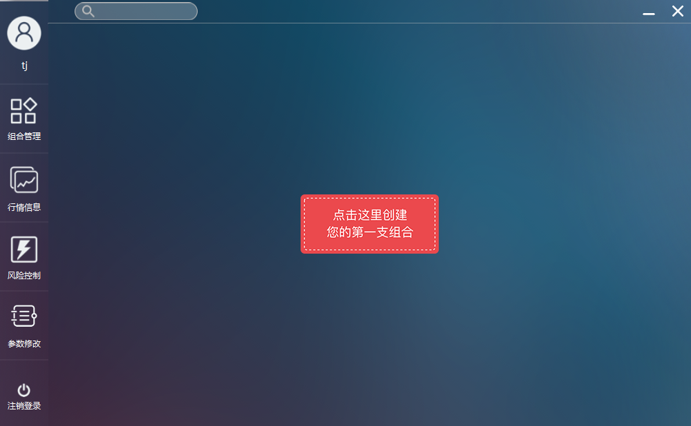

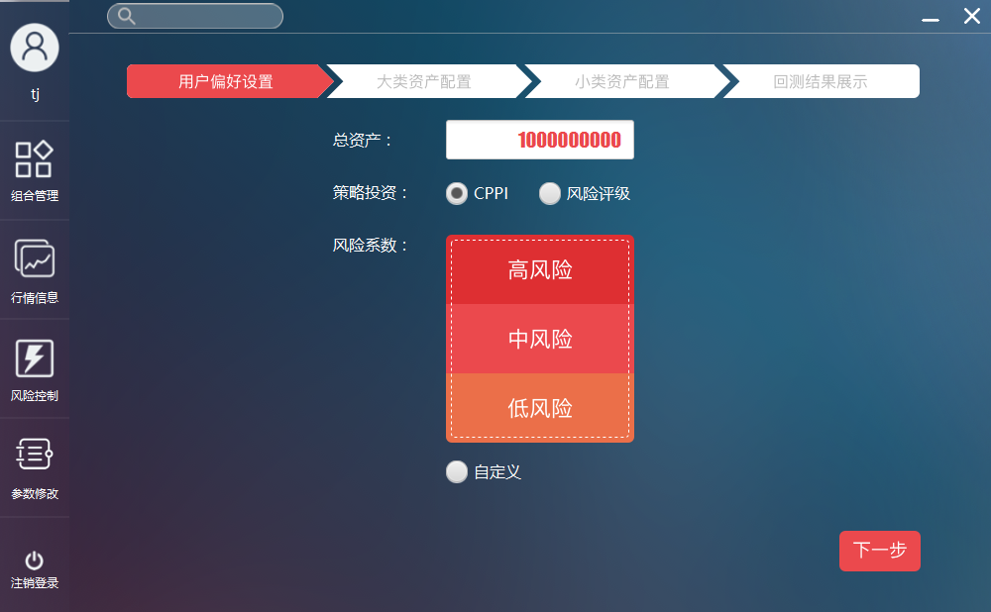

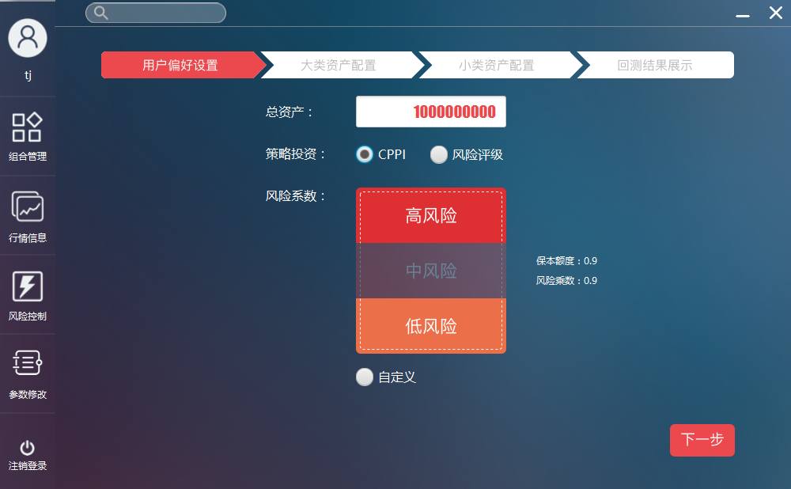

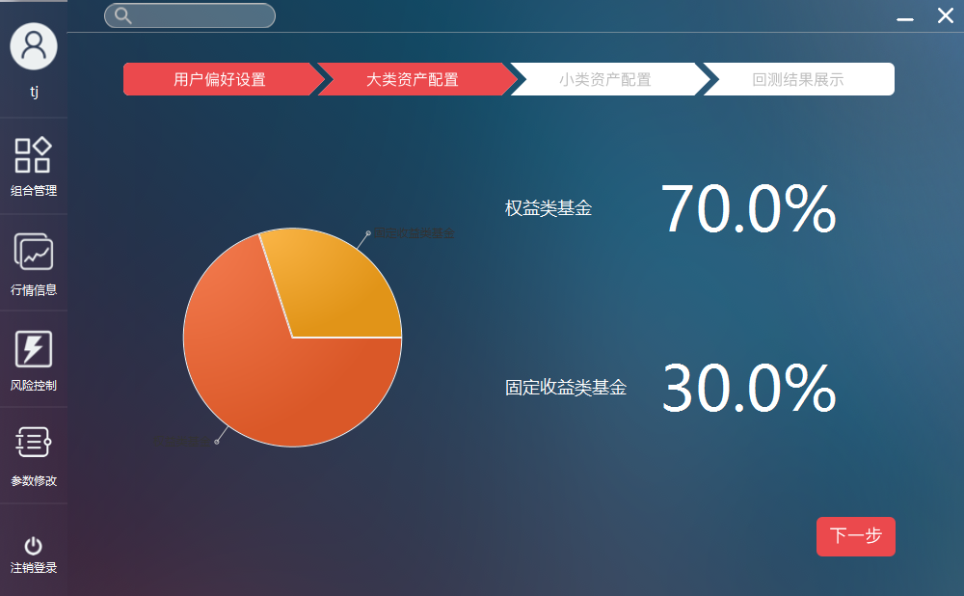

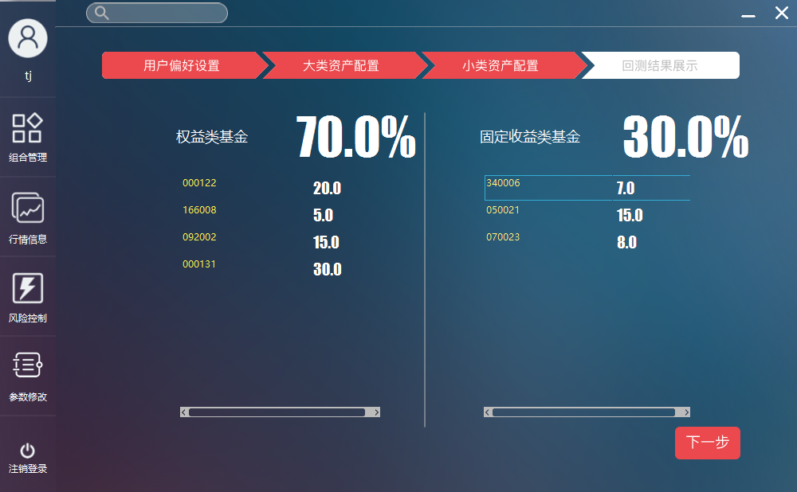

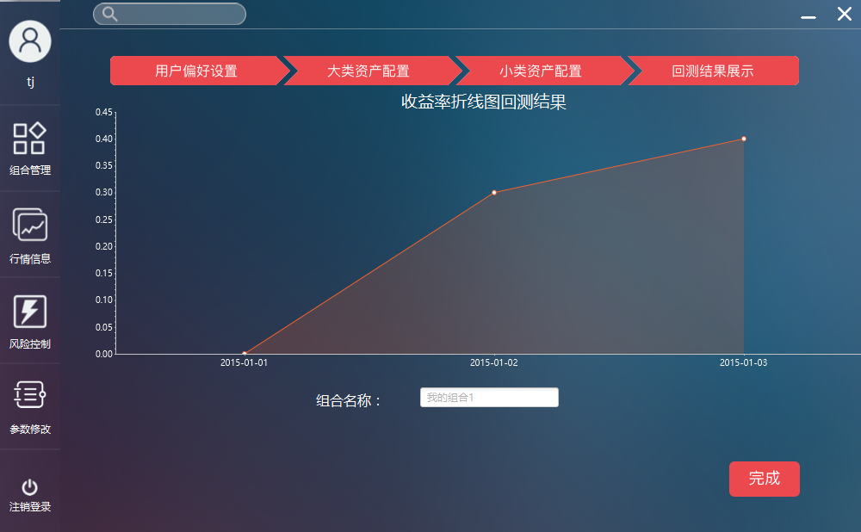

#### Generating new FOF combination

1. 选择组合管理，查看显示FOF组合基本信息、小项显示信息、总回报信息是否正确。

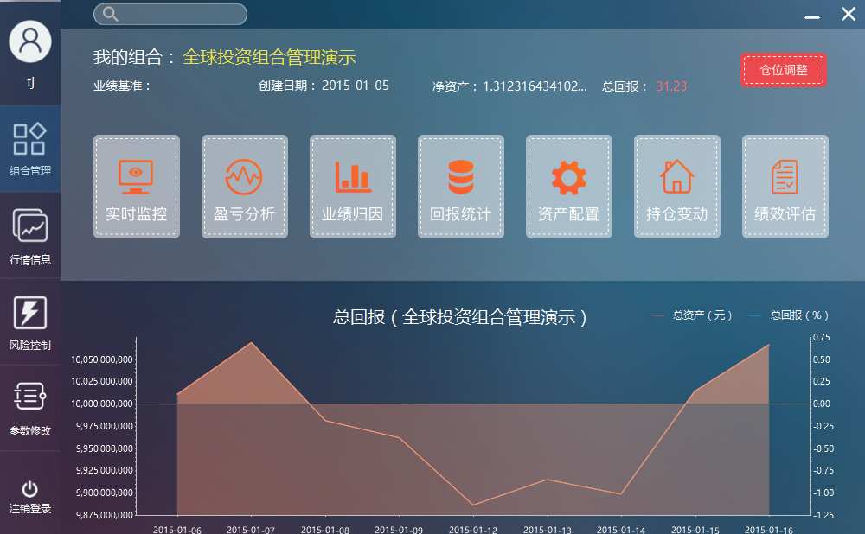

#### View realtime monitor information of the FOF

1. 点击FOF组合实时监控功能，查看FOF内组合内基金信息是否正确显示

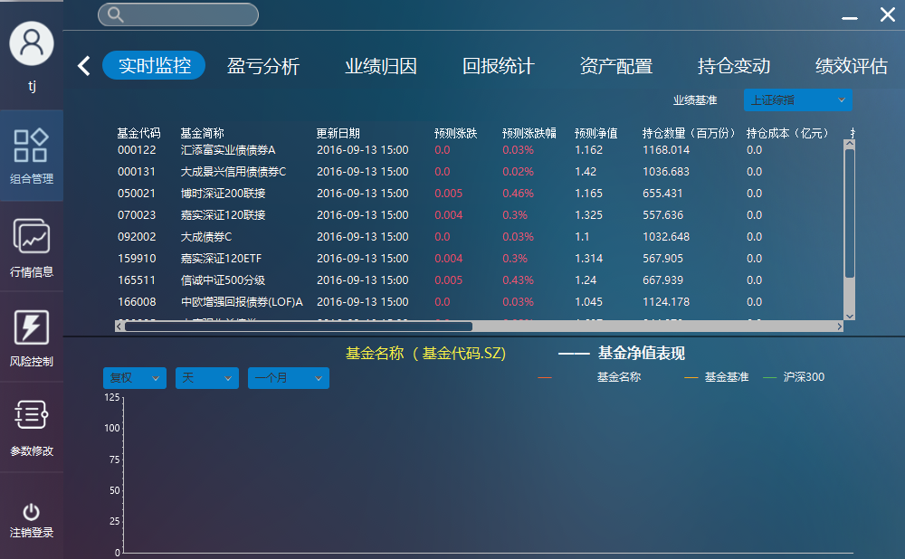

1. 单击一只基金，查看对应基金的净值表现图是否正确显示

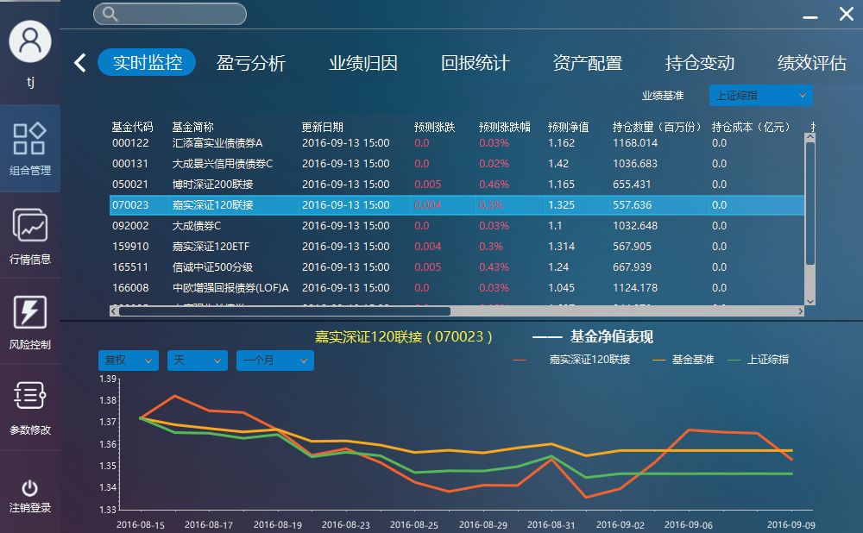

1. 更改图表中的复权信息、单位信息、区间信息，查看图表是否正确显示

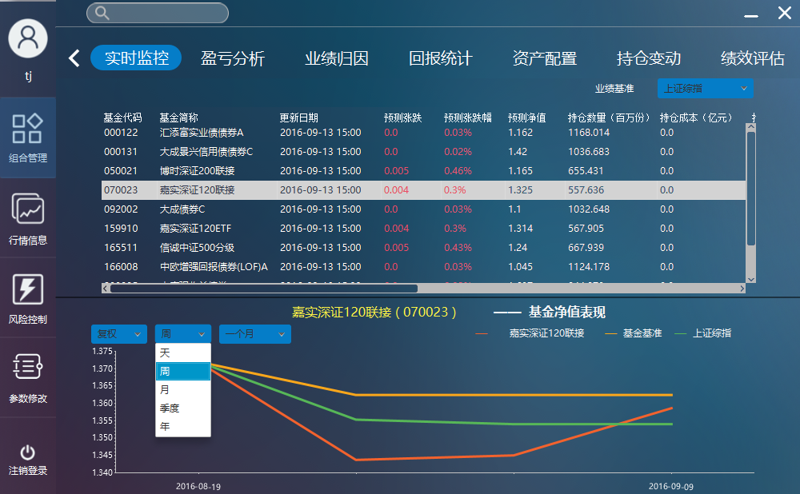

1. 更改业绩基准，查看显示信息是否正确

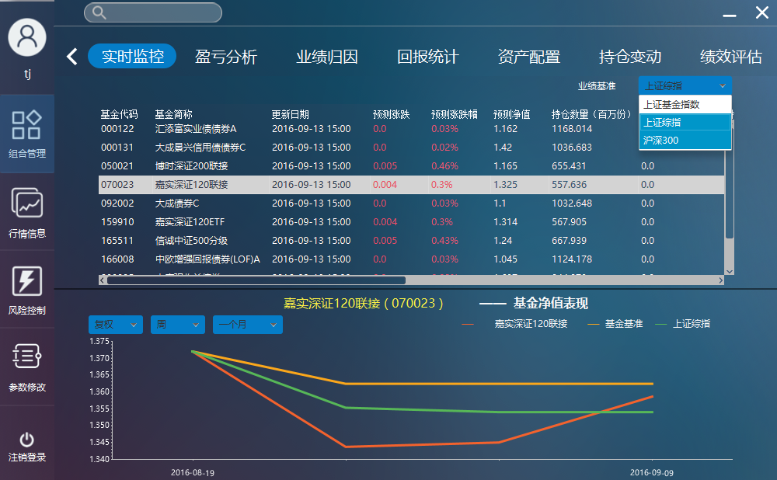

#### View profit and loss information of the FOF

1. 点击FOF组合盈亏分析功能，查看收益信息、风险指标信息是否正确显示

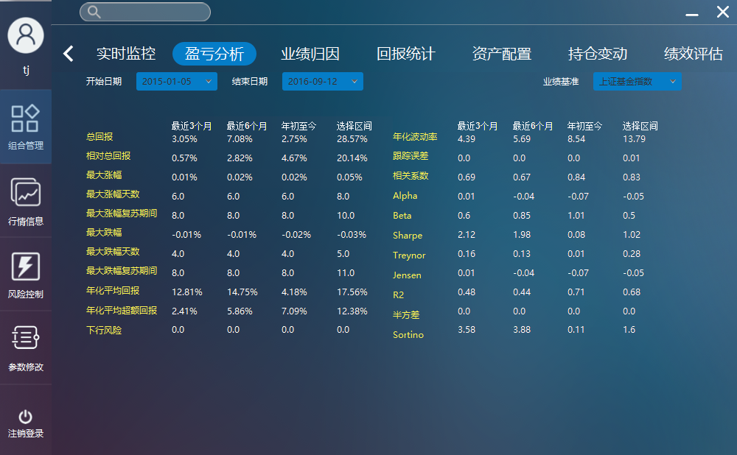

1. 更改开始日期和结束日期，查看信息是否正确更新

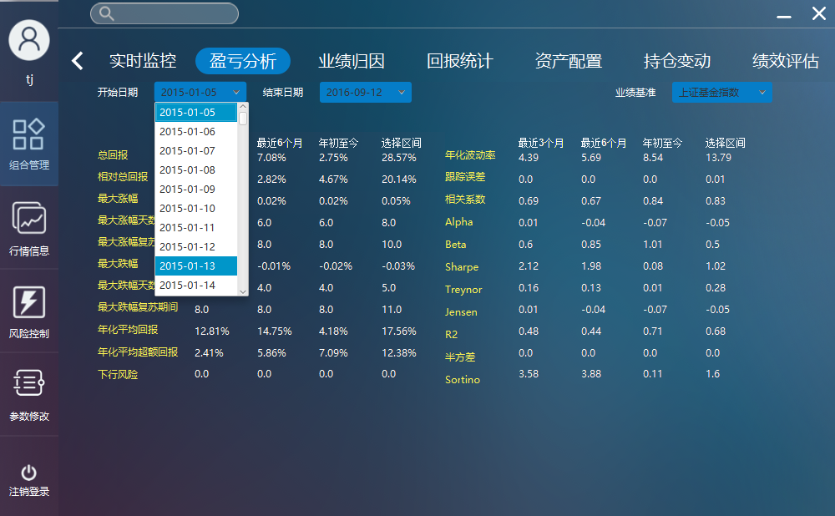

1. 更改业绩基准，查看信息是否正确更新

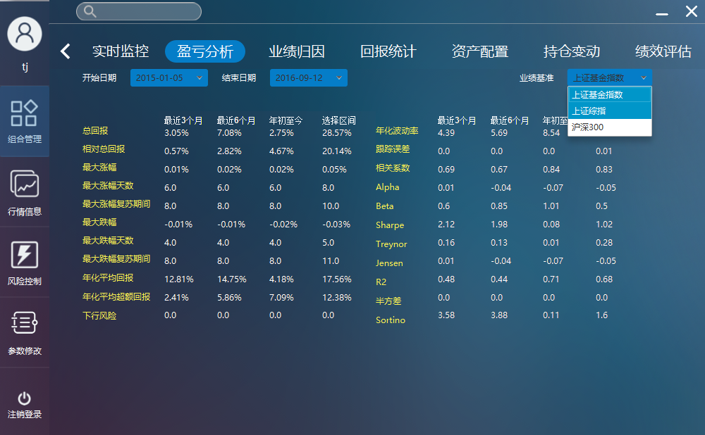

#### View report statistics information of the FOF

1. 点击FOF组合回报统计功能，查看统计信息、回报统计图表是否正确显示

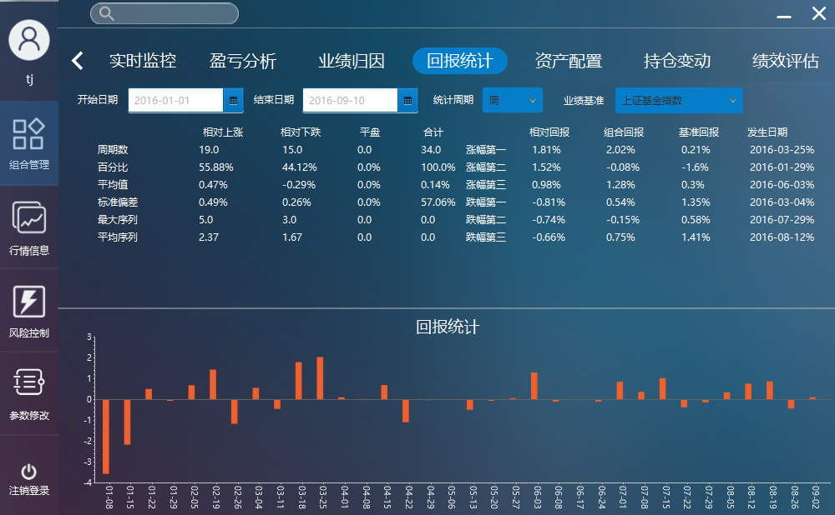

1. 更改开始日期、结束日期、统计周期，查看图表信息是否正确更新

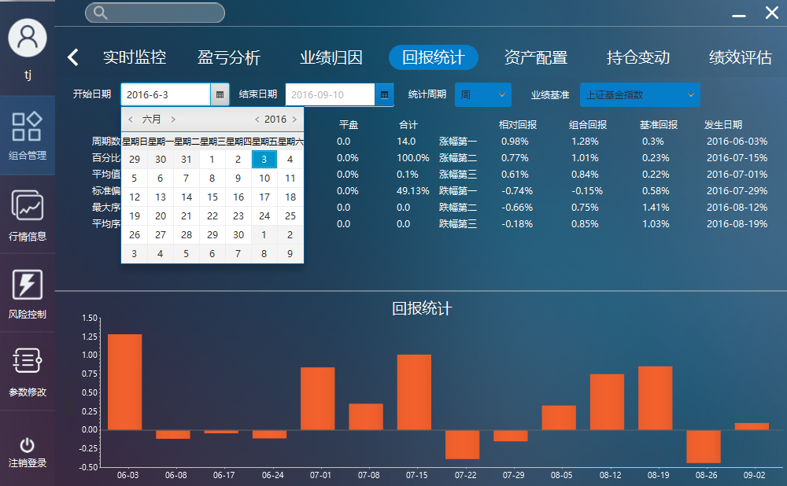

1. 更改业绩基准，查看图表信息是否正确更新

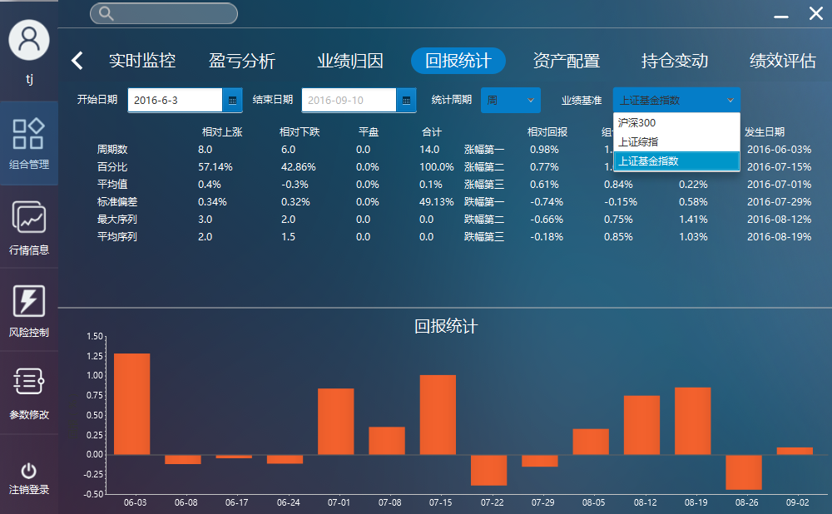

#### View report statistics information of the FOF

1. 点击FOF组合业绩归因功能，查看图表信息是否正确显示

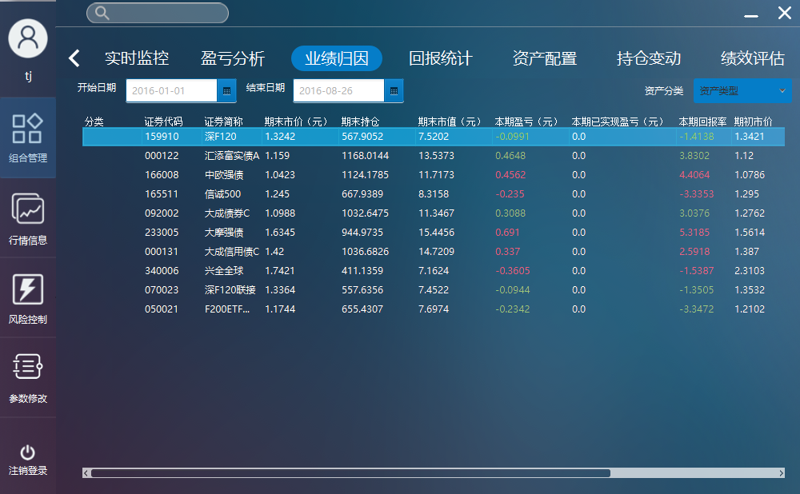

1. 更改开始日期、结束日期，查看图表信息是否正确更新

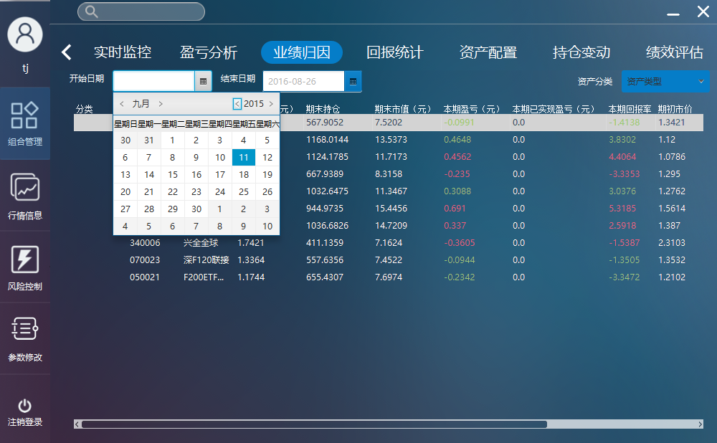

1. 更改业绩基准，查看图表信息是否正确更新

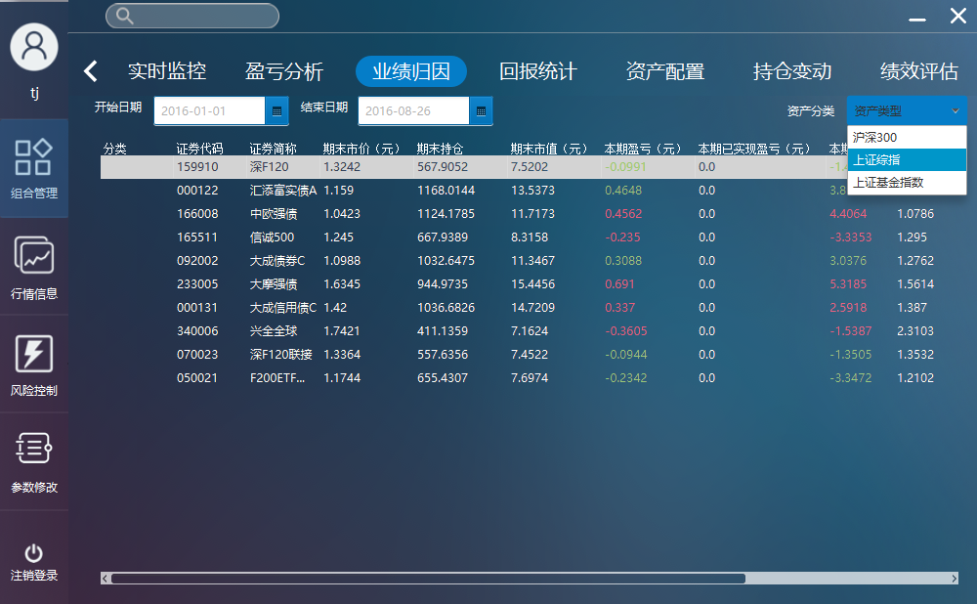

#### View asset allocation information of the FOF

1. 点击FOF组合资产配置功能，查看FOF组合内基金收益信息、净值表现图是否正确显示

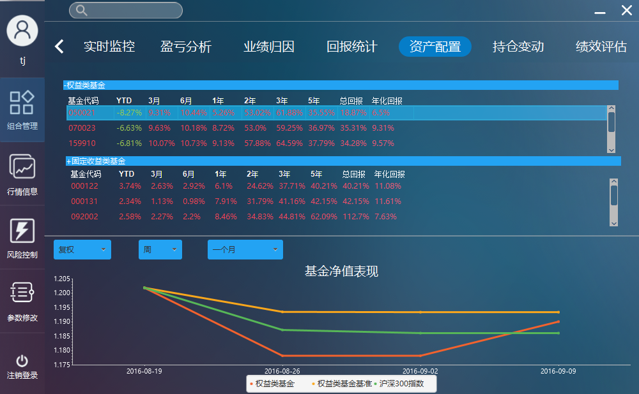

1. 单击一只基金，查看基金对应的净值表现图是否正常更新

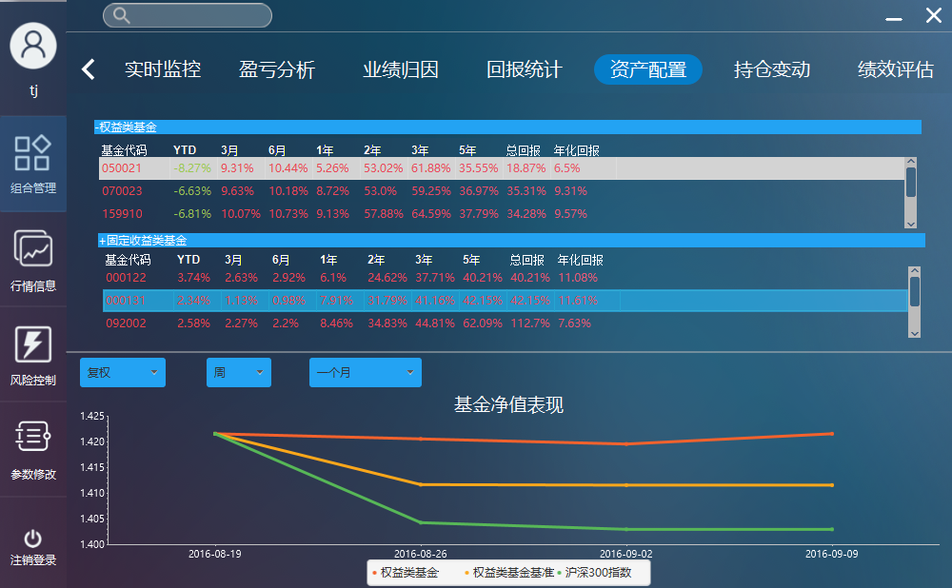

1. 更改净值表现图中的复权信息、单位信息、区间信息，查看净值表现图是否正常更新

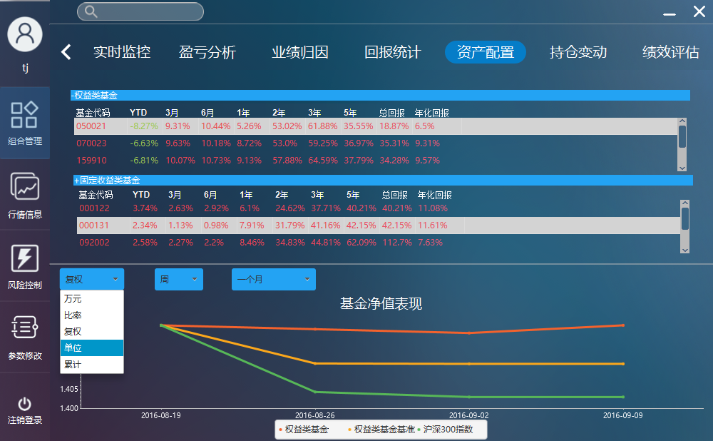

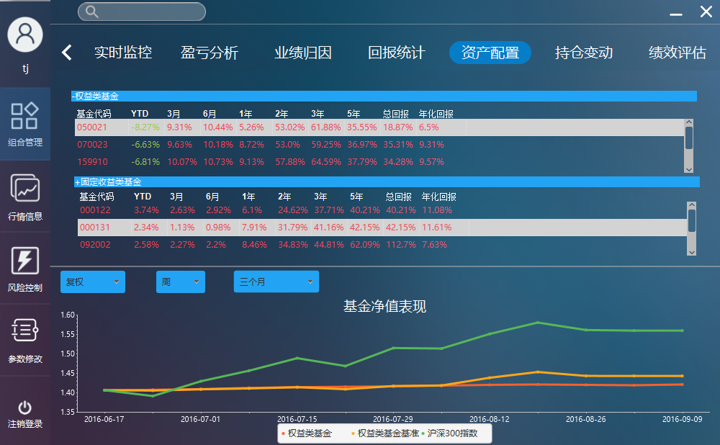

#### View position alteration information of the FOF

1. 点击FOF组合持仓变动功能，查看FOF组合历史调仓信息是否正确显示

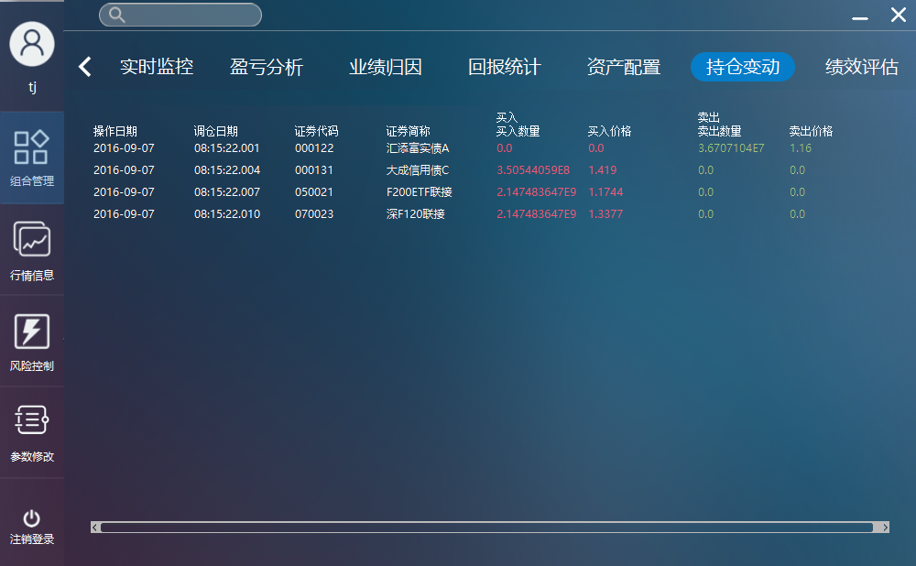

#### View performance estimation information of the FOF

1. 点击FOF组合效绩评估功能，查看FOF组合内对应基金的风险收益指标是否正确显示

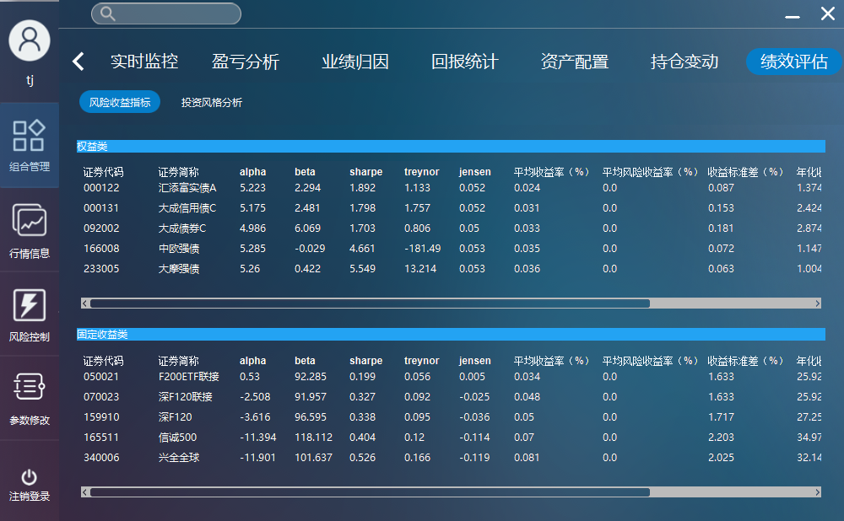

#### Adjust position

1. 点击FOF组合仓位调整功能，查看FOF组合内基金的当前权重是否正确显示

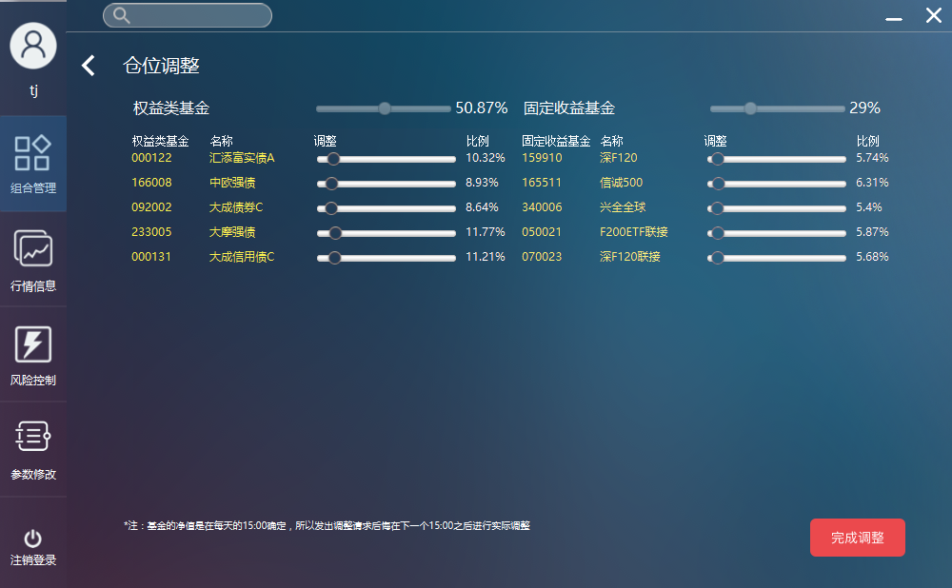

1. 使用滑动条组件调整基金权重配比，查看组件是否能够正确使用和显示信息是否正确

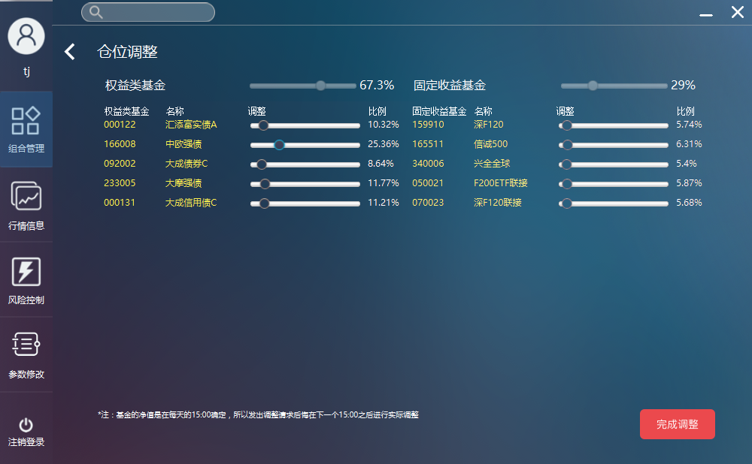

#### User information management

1. 点击账户管理信息功能，查看系统用户信息是否正常显示
2. 点击添加账户，输入新的账户信息，点击确认添加，查看系统反馈信息
3. 点击添加账户，输入数据库中已存在的账户信息，点击确认添加，查看系统反馈信息
4. 点击修改账户，更改已存在的账户信息，点击确认，查看系统反馈信息
5. 点击删除账户，删除存在的部分账户，点击确认，查看系统反馈信息

#### Modify const parameter information

1. 点击参数修改功能，查看系统内参数信息显显示

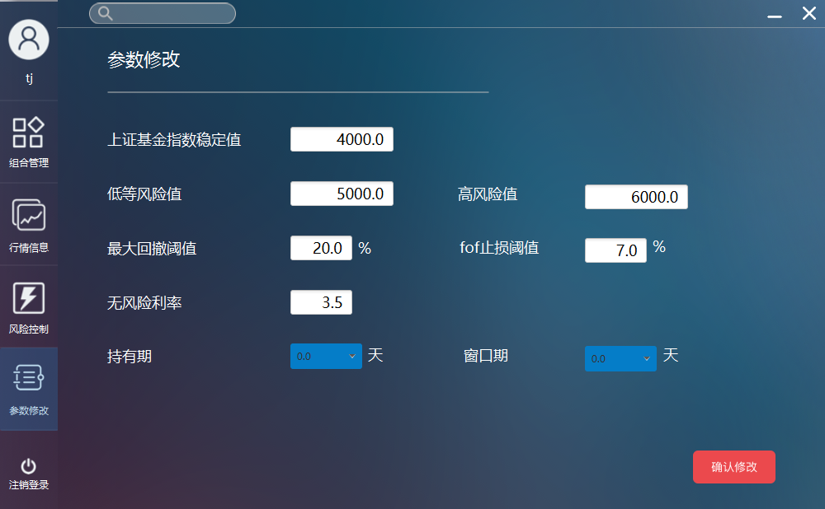

1. 修改参数中的一个或多个，点击确认更新，查看系统反馈信息

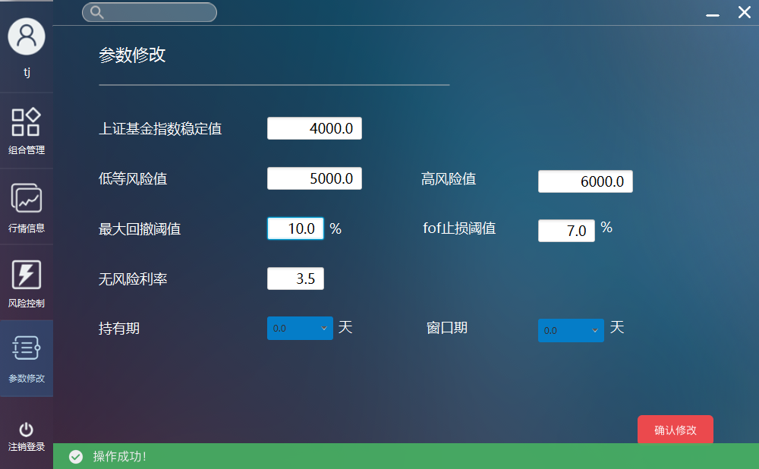

#### View risk control information

1、 点击风险控制功能，查看界面图表信息是否显示正常

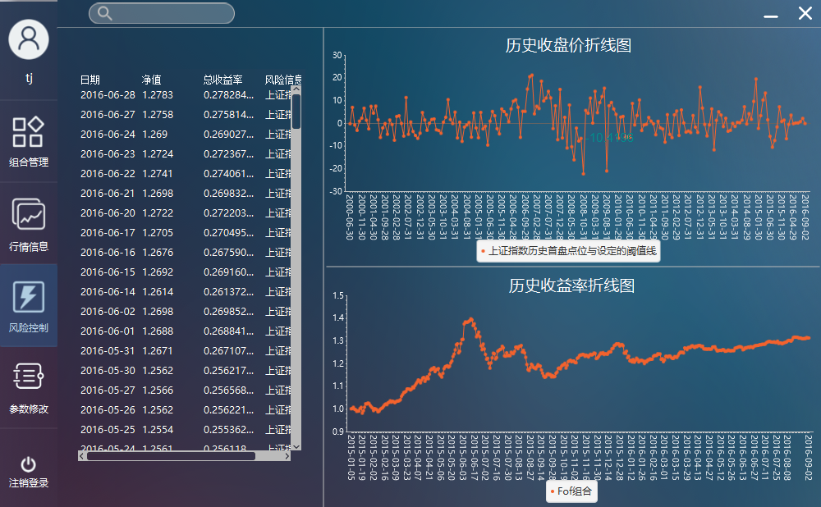

### 系统测试覆盖分析

参照需求规格文档，对文档中涉及的功能实现了90%以上的覆盖。但是实际页面需求描述无明确的定义，对输入限制无详细定义，因此没有明确的测试依据。在测试过程中，测试是根据输入字段含义、测试人员理解，以及和项目经理、开发人员沟通获得测试依据，无法保证测试依据的正确性和完整性。因此，项目组没有进行完整的、正确的无效数据的测试。此次系统测试覆盖率仍然不够，无法保证测试的有效性和正确性。

# 测试结论与建议



## 功能性

系统功能实现了需求文档的90%以上，部分细节功能需求未能实现，符合一个软件实际的开发完成度。

## 易用性

现有系统实现了如下易用性：

1. 输入错误提示信息的正确性、可理解性、一致性
2. 系统帮助信息的准确性、有效性
3. 产生错误时，用户能得到及时更正
4. 系统在界面、风格、操作等方面具有一致性
5. 界面的有效反馈以及反馈的及时性

现有系统存在如下易用性缺陷：

1. 部分界面排版不美观
2. 部分界面刷新过慢

## 可靠性

现有系统的可靠性控制基本达标，因为不存在过多的用户数据上传请求，不存在大的隐患。

现有系统有一定的容错能力，当系统有错误发生时，大部分错误可以得到修正，但部分错误无法及时修正。

现有的客户具有一定得并发性，在客户量不是很大的时候，客户端与服务端具有良好的并发性。

## 兼容性

现有系统基于 Java 虚拟机上运行，理论上支持所有能够安装 Java 虚拟机的操作系统。项目组仅做了 Windows8.1、Windows10 系统下的兼容性测试，表现良好。

## 安全性

现有系统控制了以下安全性问题：

1. 用户名和密码对大小写敏感
2. 对传输与存储数据进行加密（特别是密码的加密传输与储存）
3. 对数据进行定期备份，保证意外情况发生时系统能保留重要数据和尽快回复系统

现有系统未控制以下安全性问题：

1. 登陆错误次数限制
2. 并发测试未全面做，可能有并发上的问题